SUSMITA LAMICHHANE

# Summary

Web Developer specializing in backend development. Experienced with all stages of the development cycle for dynamic web projects. Well-versed in numerous programming languages including HTML5, Python, OOP, JavaScript, CSS, MySQL.

# Technical Skills

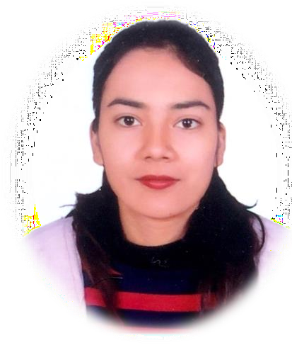**Languages**:python,C,C++ **Web Design**: HTML, CSS, Django_Framework and

Django Re st_Framework

**Database**: Postgresql

**Graphics Design**: Adobe Photoshop **Algorithm and Datastructure** Problem solving using c (github link: https://github.com/Susmita055/data- structure-using-c),

**Familiar with Git and Github**

# Contact

## Address:

Lazimpat-02,Kathmandu

## Phone:

9845340172

## Email:

[Smileysusmita2055@gmail.com](mailto:Smileysusmita2055@gmail.com)

# Languages

Nepali English Hindi

# Hobbies

Modelling Travelling

# Personal Abilities

* Self- disciplined
* Honest and full of positive -enthusiasm
* Ability to work with - team/group
* Good communication skill

# Experience

**Python Developer** - 01/2021 to 10/2021

**Techno Byte**, Bhaktapur

* + simple, intuitive interactions and experiences.
  + Develop project concepts and maintain optimal workflow.
  + Work with senior developer to manage large projects for corporate clients.
  + Complete detailed programming and development tasks for backend public and internal websites as well as challenging back-end server code.

# Internship

**Backend Development Using Django** - 07/2020 to 10/2020

**Achievrs Groups And Research Center**, putalisadak, kathmandu

* + Knowledge about setting up Python REST API Frame work using DRF
  + Exposure on implementing authentications using ORM libraries.
  + Used SQL alchemy as ORM for writing the ORM Queries
  + Good experience in working with various Python Integrated
  + Development Environment like pycharm, vsCode, idle and Jupyter Notebook
  + Working experience on GIT
  + Strong analytical and problem-solving skills , always striving for new knowledge

# Education

Bachelor of Science in Computer Science and Information Technology Amrit Science Campus, Lainchaur, Kathmandu

# Projects

Soft Skills

* Ms Word
* Excel
* PowerPoint
* Content/Technical Writing
* Photoshop illustrator

Coding Environments

* VS Code
* Sublime Text Editor
* pycharm
* E-Commerce Website Using Django
  + Full featured shopping cart with esewa & khalti payments
  + Product search, carousel, pagination & more
  + Admin area to manage customers, products & orders
  + Implemented authentication features Github Link - [https://github.com/Susmita055/e- commerce-website-using-django](https://github.com/Susmita055/e-commerce-website-using-django)
* Hospital Appointment Website
  + Implemented authentication features with social login
  + scraped API to collect covid data and presented as the form of dashboard
  + Added feature to allow user to view their appointments history and user profile
  + Appointment form , registrations process, password reset features

Github Link- <https://github.com/Susmita055/HOSPITAL>

* Authentication API (Django Rest_framework)
  + Created a api using class based view functions
  + Implemented jwt authentication in api
  + Unit testing for each created end points Github Link- [https://github.com/Susmita055/Authentication-](https://github.com/Susmita055/Authentication-_achievers)

[_achievers](https://github.com/Susmita055/Authentication-_achievers)

* + - Post Article (Django)
      * CRUD operation in post
      * File uploading , comment, subscribe, mailing functionality
      * Paginating the post Github Link-

<https://github.com/Susmita055/firstproject>